**PRACTICAL 1**

**Aim: Write a C program to read 4 int numbers from user and find the sum, product and average of those numbers.**

**Program:**

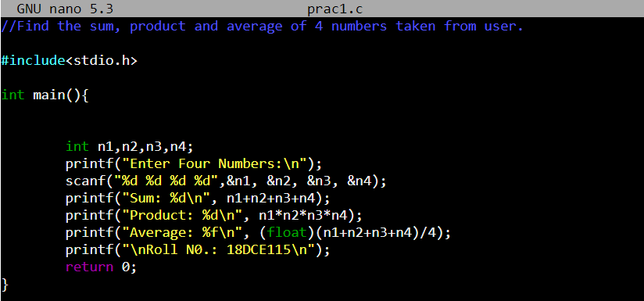

**Output:**

